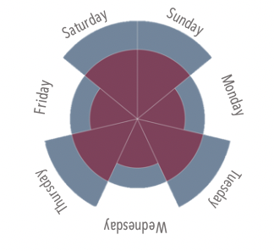
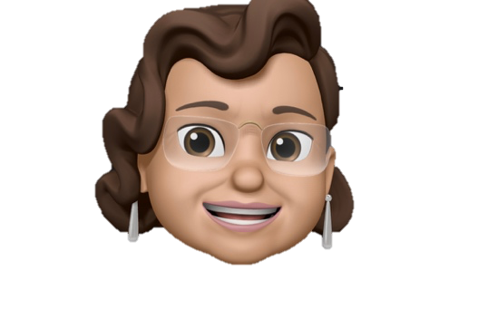

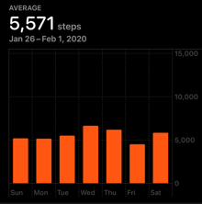
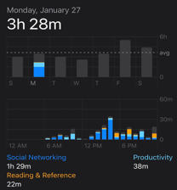

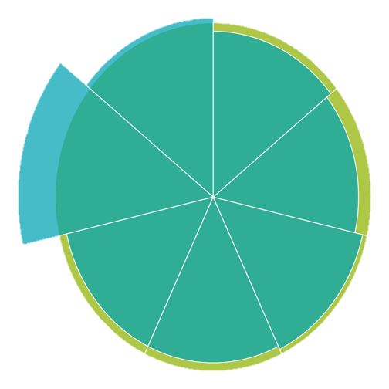
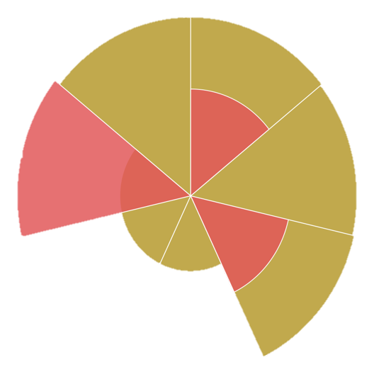



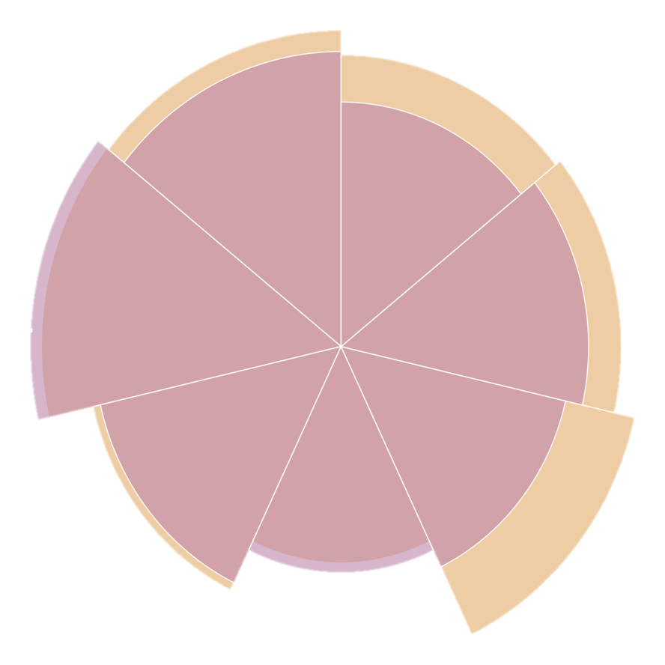
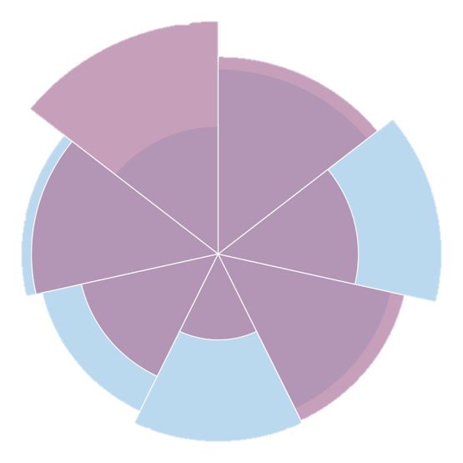


Findings
Boomers V.S. Millennials
A Look at How A Mother and Daughter Spend Their Time
May Help Two Generations Understand Each Other

Millennials and Boomers, two generations that never seem to get along. Boomers accuse millennials of being lazy, entitled and aloof while millennials -when they’re not juggling student loan debt and a dwindling housing market- view boomers as irresponsible and ‘silent’. Focusing on commonalities, these two may have more in common than they think and can help one another cross the generational bridge. Afterall, they’re related.

A look into a week of activities between one Carolina based mother and her bustling New York City daughter might finally help boomers and millennials bury the hatchet and bust a few myths between one another.

Age: “That’s private, just put ‘Mom’” Age: 28 yrs. old

Location: Raleigh, North Carolina Location: Brooklyn, NYC

Occupation: Health Care Occupation: Program Analyst

Meet the Candidates

When we consider our basic everyday tasks, Millennials and Boomers share similar habits. Proving that finding common ground might be easier than the media would like us to think.

Physical Activity
“Millennials are lazy and don’t want to work hard”

Exercise

Daily Steps
Commuting
Conclusion

Two research methods were used during this study:
- Records/Documentation
- Interview/Oral History

Taking advantage of the internal accelerometer and monitoring apps in Apple products, daily screen and physical activity data for each candidate was collected using the ‘Screen time’ and ‘Health’ app and then visualized using Tableau.

Data not commonly tracked, such as daily cooking and travel time was gathered during a regular phone call between mother and daughter.

Interview
Eating out/Delivery

Cooking/Meal Prep
Cooking, Eating
“Boomers don’t take their health seriously”

Daily Screen time
Reading & Referencing
Entertainment
Social Networking
Screen Activity
“Millennials are disconnected and obsessed with their phones”
How to Read It
Each slice of the chart represents a day of activity. Days compare mother and daughter using the colour legend below. Weeks start on Sunday and ends at Saturday in a clockwise direction.
iPhone/iPad
The Generation Feud

Mother
Daughter

Data

